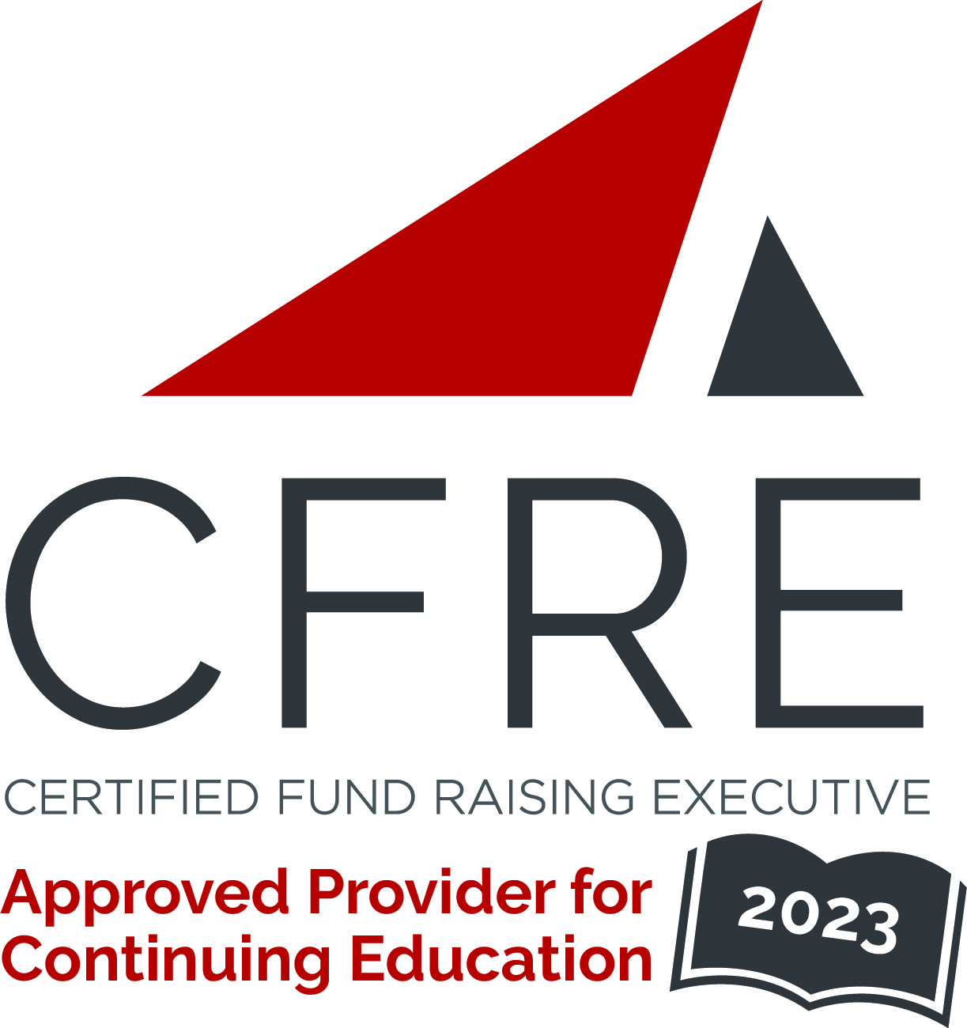  CFRE International has developed this form as a way for you to quickly track (and keep in your files!) the continuing education sessions you have attended. Simply check the boxes next to the sessions you attended. At the end of the conference, add up the total number of hours. Keep this sheet and you will be ready to complete your application form. All of the session slots listed are eligible for continuing education points on your CFRE application for initial certification and/or recertification. Sessions not listed here are not eligible for points. |  | CONTINUING EDUCATION POINTS TRACKER

Activity Organizer: CCAE
Title of Activity: 2023 Colleges & Institutes Summit - Toronto
Names of Presenter(s): Various
Dates and Location: 11 & 12 Oct 2023 – Toronto

Date: Oct 11, 2023
Session 1: 10:00-11:15am - (1.25 pts)
- New-Age Networking

Date: Oct 11, 2023
Session 1: 10:00-11:15am - (1 pt)
- Meeting the Moment: Philanthropic Trends 2023

Date: Oct 11, 2023
Session 1: 10:00-11:15am - (1 pt)
- Philanthropic Naming & Value Assessment]

Date: Oct 11, 2023
Session 1: 10:00-11:15am - (1 pt)
- Know your worth: navigating complex donor expectations

Date: Oct 11, 2023
Session 1: 10:00-11:15am - (1 pt)
- Discussion Session

Date: Oct 12, 2023
Session 1: 9:00-10:00am - (1 pt)
- Building from the ground up: Investing in our Alumni and Community

Date: Oct 12, 2023
Session 1: 9:00-10:00am - (1 pt)
- Beyond the profile: turning alumni communications into lasting - and valuable - relationships
Date: Oct 12, 2023
Session 1: 9:00-10:00am - (1 pt)
- Be Your Own Consultant: Finding Clarity in Chaos

Total number of points attained: ____

