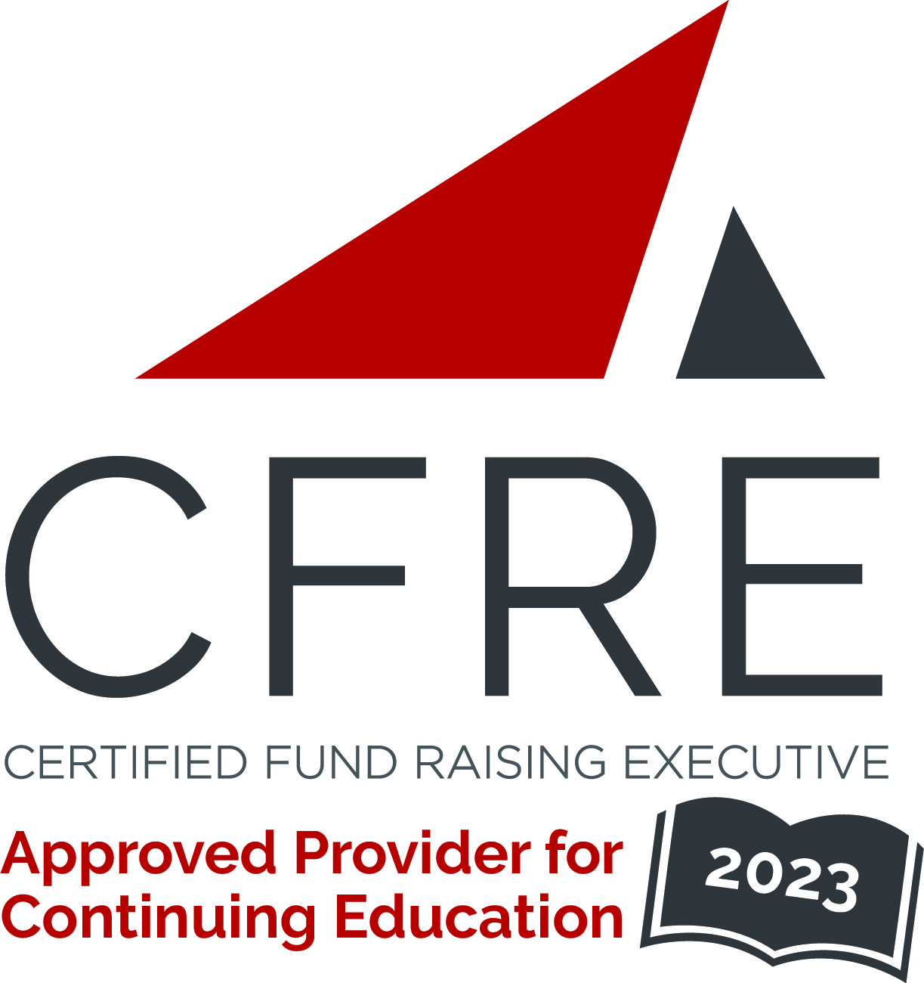  CFRE International has developed this form as a way for you to quickly track (and keep in your files!) the continuing education sessions you have attended. Simply check the boxes next to the sessions you attended. At the end of the conference, add up the total number of hours. Keep this sheet and you will be ready to complete your application form. All of the session slots listed are eligible for continuing education points on your CFRE application for initial certification and/or recertification. Sessions not listed here are not eligible for points. |  | CONTINUING EDUCATION POINTS TRACKER

Activity Organizer: - [CCAE]
Title of Activity: - [Independent School Summit Oakville
Names of Presenter(s): -
Dates and Location: - 6-7 Feb, 2024

Date: 6 Feb, 2024
Sessions 1-5: 9:00 [am] – 4:30 [pm] (5 pts)
- [Opening Keynote: Innes Van Nostrand
- [Finding Common Ground] Brendan Dellandrea & Hailey Meslin
- [Ethics in Fundraising] Tanya Rumble
- [Advancement in the Digital Age: Zahra Valani
- [Open Season – Festivus and Firefly discussion session] Rakesh Tripathi

Date: 7 Feb, 2024
Session 6-8: 9:00 [am] – 4:30 [pm] (3 pts)
- [Demonstrate the value of the Advancement Office ] Jill Cannon
- [Session Title]
- [Support Your Alumni Community] Marin Anderson & Brian Robinson

Total number of points attained: __________

