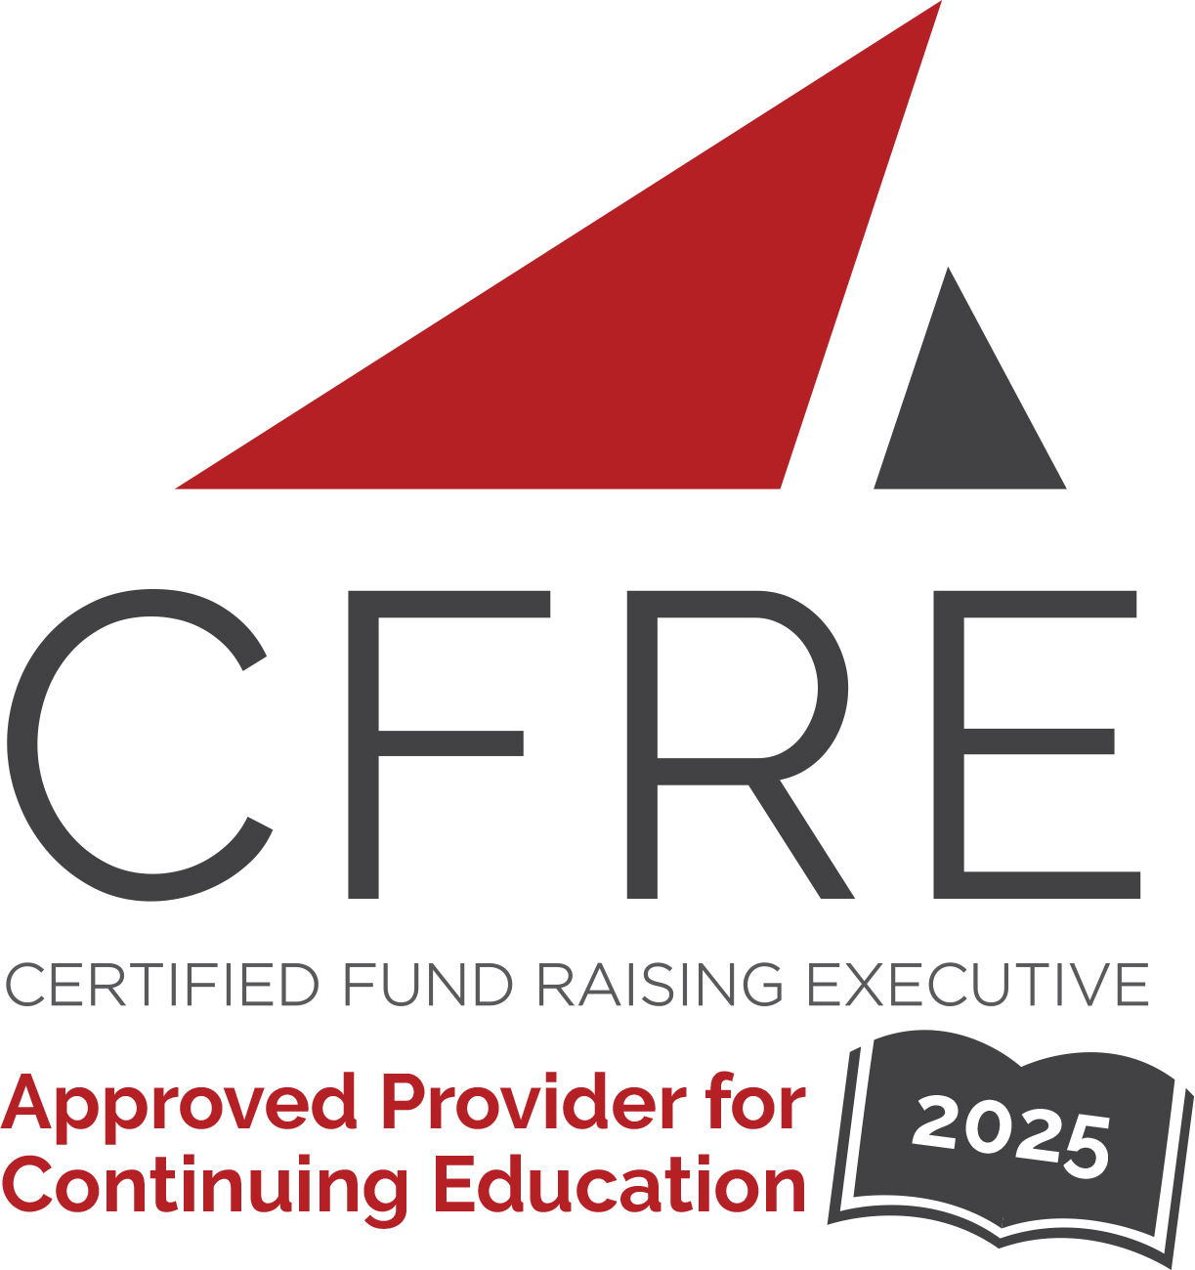  CFRE International has developed this form as a way for you to quickly track (and keep in your files!) the continuing education sessions you have attended. Simply check the boxes next to the sessions you attended. At the end of the conference, add up the total number of hours. Keep this sheet and you will be ready to complete your application form. All of the session slots listed are eligible for continuing education points on your CFRE application for initial certification and/or recertification. Sessions not listed here are not eligible for points. |  | CONTINUING EDUCATION POINTS TRACKER

Activity Organizer: - CCAE
Title of Activity: - Development for Deans
Names of Presenter(s): - Andrea Morris, University of Calgary & Gillian Morrison, University of Toronto
Dates and Location: - 26 February 2025 – Toronto, Ontario

Date: 26 February 2025
Sessions All Day: 8:30 am – 4:30 pm ET (7 pts)
- 2025 Development for Deans - Toronto

Total number of points attained: __________

