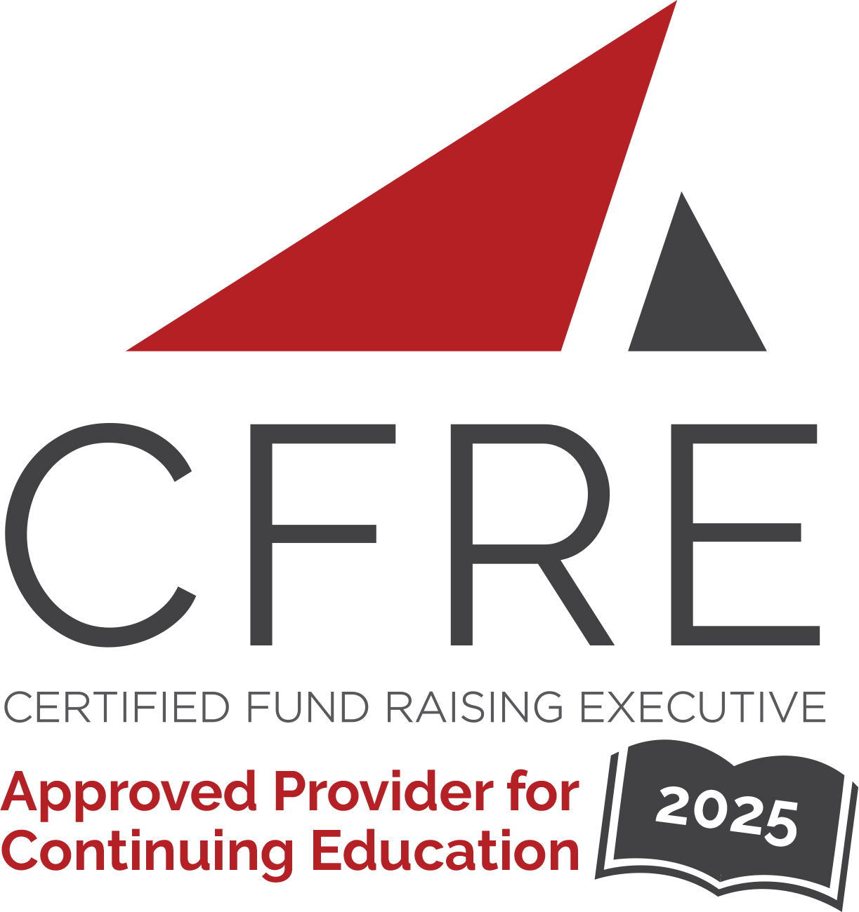  CFRE International has developed this form as a way for you to quickly track (and keep in your files!) the continuing education sessions you have attended. Simply check the boxes next to the sessions you attended. At the end of the conference, add up the total number of hours. Keep this sheet and you will be ready to complete your application form. All of the session slots listed are eligible for continuing education points on your CFRE application for initial certification and/or recertification. Sessions not listed here are not eligible for points. |  | CONTINUING EDUCATION POINTS TRACKER

Activity Organizer: - CCAE
Title of Activity: - Independent School Summit
Names of Presenter(s): - Various
Dates and Location: - 11 & 12 February 2025 – Calgary, Alberta

Date: 11 February 2025
Sessions All Day: 8 am – 3:30 pm ET (4 pts)
- Opening Keynote: Journeys of Philanthropy Ross W. Marsh, Samantha Kolias-Gunn & Ellie Siebens
- Heads and Advancement: Together Forever! Dr. Leanne Foster & Martha Drake
- Case study: High-performance volunteering opportunities in campaign Brendan Dellandrea
- 2022 Stewardship Survey Results: Sharing Best Practices George Stanois

Date: 12 February 2025
Sessions Half Day: 8:15 am – 1 pm ET (3.5 pts)
- Idea Fair – Discussion Session
- Collaborative Impact: Harnessing Community Relations for Academic Excellence and Brand Strength Hallie McClelland & Jennifer Brett Fraser
- Collaborative Leadership in Action: Driving School-Wide Success Through Integration, Messaging, and Mentorship Erlynn Gococo, Lauren Somerville & Leslie bergin

Total number of points attained: __________

