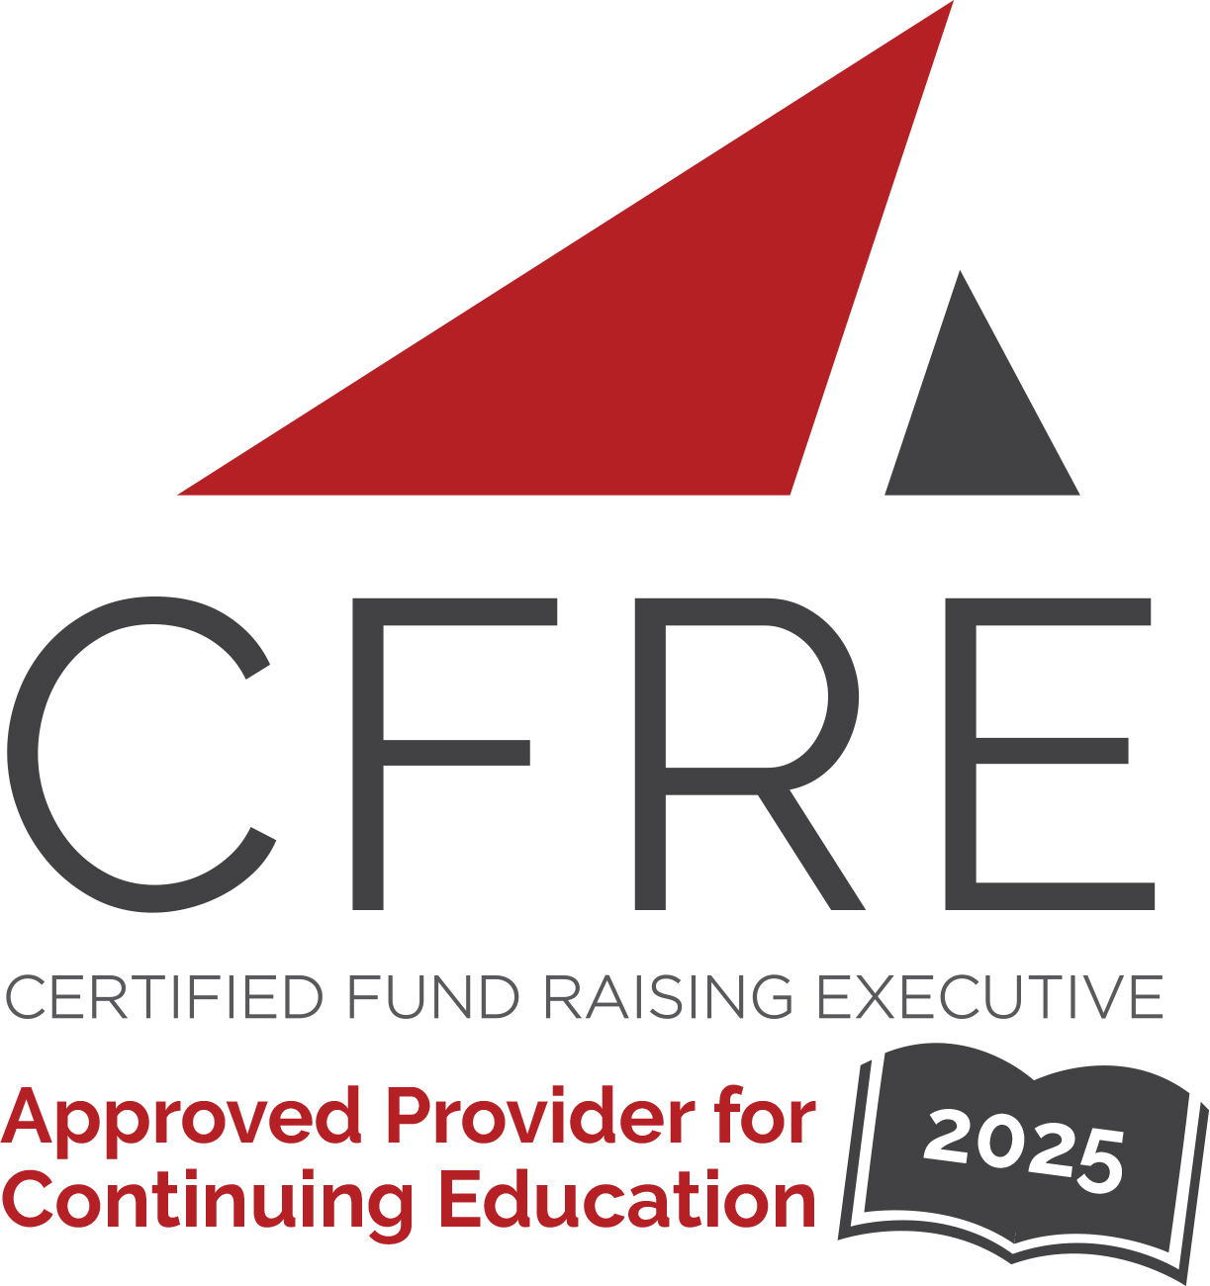  CFRE International has developed this form as a way for you to quickly track (and keep in your files!) the continuing education sessions you have attended. Simply check the boxes next to the sessions you attended. At the end of the conference, add up the total number of hours. Keep this sheet and you will be ready to complete your application form. All of the session slots listed are eligible for continuing education points on your CFRE application for initial certification and/or recertification. Sessions not listed here are not eligible for points. |  | CONTINUING EDUCATION POINTS TRACKER

Activity Organizer: - CCAE
Title of Activity: - Summit for Alumni Professionals
Names of Presenter(s): - Various
Dates and Location: - 2 & 3 April 2025 – Toronto, ON

Date: 2 April 2025
Sessions All Day: 9 am – 5 pm ET (5 pts)
- Opening Keynote: Steve Orsini, President and CEO, Council of Ontario Universities
- From Local to Global: Building a Global Alumni Program on a Shoestring Budget Prikankshit Mor, York University
- Building philanthropy into traditional alumni events Gabriela Rappell, Queen's University
- The Email Renaissance: How Less Became More Derek Szilagyi, & Steve Frangakis, Communications Officer, Wilfrid Laurier University

- Creativity Mastermind - Discussion Session

Date: 3 April 2025
Sessions Half Day: 9 am – 12 pm ET (2 pts)
- A Holistic Approach to Career Networking for Black Alumni and Students
Ivan Nguyen & Preeti Pasupulati, University of Toronto
- Innovations in Alumni Awards Programming & Events Kairi Williams & Heather Auden, York University

Total number of points attained: __________

