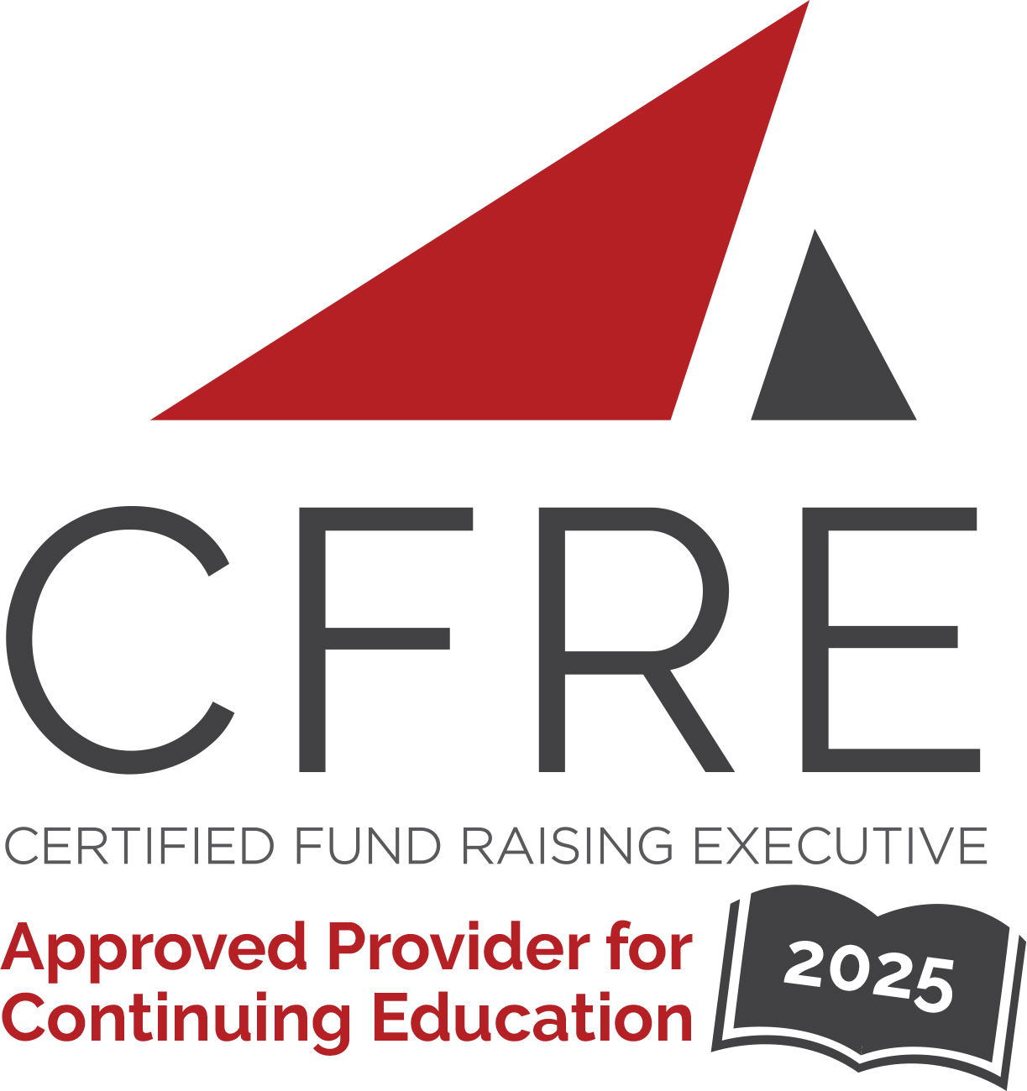  CFRE International has developed this form as a way for you to quickly track (and keep in your files!) the continuing education sessions you have attended. Simply check the boxes next to the sessions you attended. At the end of the conference, add up the total number of hours. Keep this sheet and you will be ready to complete your application form. All of the session slots listed are eligible for continuing education points on your CFRE application for initial certification and/or recertification. Sessions not listed here are not eligible for points. |  | CONTINUING EDUCATION POINTS TRACKER

Activity Organizer: - Canadian Council for the Advancement of Education
Title of Activity: - CCAE National Conference
Names of Presenter(s): - Various
Dates and Location: - 29 April – 01 May, 2025 – Quebec, Canada

Date: 30 April, 2025
Session 1: 8:30am – 9:45am (1.25 pts)
- Opening Keynote Presentation

Date: 30 April, 2025
Session 2: 10:00am – 11:00am (1 pt)
- We Can’t Do What We Can’t Track
- Charting a New Course: Creating a Customer Experience Revolution
- Partner with Your University Libraries to Meet (And Exceed) Your Engagement Goals
- A Co-Leadership Approach – Optimizing Resources for Impact
- Strategy Lab: Data Analytics

Date: 30 April, 2025
Session 3: 11:30am – 12:30pm (1pt)
- The Evolution of an Awards Program
- Lessons Learned From Building a Digital Engagement Strategy From Scratch
- The Long Game: The Importance of Passion, Partnership and Patience in Philanthropy
- Senior Leaders Panel
- Strategy Lab: Principal Gifts

Date: 30 April, 2025
Session 4: 1:30pm – 2:15pm (1 pt)
- Evolving Development Writing for the 21st Century: Crafting the Pitch-Perfect Pitchdeck
- Polytechnic Proud: Strategic Alumni Engagement
- Quand la Philanthropie rencontre l’Histoire!
- Building a High-Performance Major Gifts Culture: A Dean-Advancement Partnership in Action

Date: 30 APril, 2025
Session 5: 4:00pm – 5:00pm (1 pt)
- President’s Panel

Date: 01 May, 2025
Session 6: 9:00am – 10:00am (1 pt)
- Taking the Ego Out of Collaboration: Two Alberta Schools Join Forces with a Goal to Raise $15M
- The Yellow Jersey: Elevate Your Team Members to Success
- Sound Strategy: How UM’s Podcast Supports Advancement and a Culture of Big Thinking
- Engaging New Grads with Career Services
- Strategy Lab: Annual Giving

Date: 01 May, 2025
Session 7: 10:30am – 11:30am (1 pt)
- Demystifying Legacy Giving: Tools, Tips and Tricks to Inspire Legacy Giving Conversations
- Artificial Intelligence for Graduate Relations
- L'intelligence artificielle au service des relations diplômés

Date: 01 May, 2025
Session 8: 1:15pm – 2:00pm (1 pt)
- The Uphill Battle Against Short-Term Tactics in Marketing: A Strategic Approach in Higher Education
- The Space Gal at Mac Eng
- Stewardship is Mission Critical for Campaign Success

Date: 01 May, 2025
Session 9: 2:30pm – 3:30pm (1 pt)
- How Can We Assist You? The Impact of a $1 Billion Campaign on Support Services for Philanthropic Advisors
- The Power of People: Sparking a World-Class Event in 15 Days

Total number of points attained: __________

